A000-Asia-Thailand-Ban Chiang-Bangle-Shell-3600 BCE

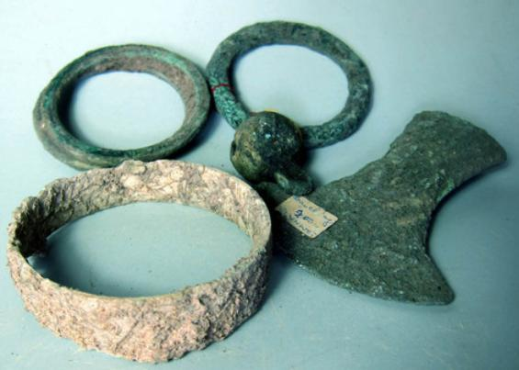

Fig. 1. Thailand-Ban Chiang-Bangle-Shell-3600 BCE

Case no.:5

Accession Number:

Formal Label: Thailand-Ban Chiang-Bangle-Shell-3600 BCE

Case no.:

Accession Number:

Formal Label: Thailand-Ban Chiang-Bangle-Shell-3600 BCE

Display Description: This Ban Chiang shell bangle may date to the earliest graves c 2100 BCE, before the smelting of bronze, since crucibles and bronze fragments do not show up in the archaeological record until 2000 BCE

LC Classification: DS589.B17

Date or Time Horizon: 300 BCE-300 CE

Geographical Area: Ban Chiang, Udon Thani, Thailand

Map:

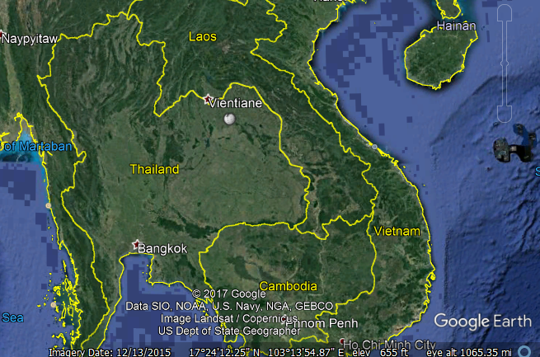

Fig. 4. Ban Chiang is near Vientiane

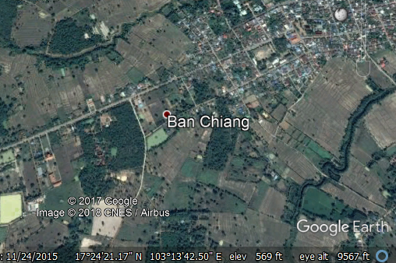

Fig. 6. Detail of Ban Chiang location

GPS coordinates: [17°24′25″N 103°14′29″E](https://tools.wmflabs.org/geohack/geohack.php?pagename=Ban_Chiang&params=17.4069_N_103.2414_E_type:landmark_region:TH-41)

Cultural Affiliation: Ban Chiang

Medium: Clay

Dimensions: 14 cm at widest and 14.5 cm high

Weight: 660 gm

Condition: original

Provenance: Thailand

Discussion:

A date of 2100 BCE was obtained from rice phytoliths from inside a grave vessel of the lowest grave. A dating program for this site has involved dating the bones from the people who lived at Ban Chiang and the bones of animals interred with them. The resulting determinations have been analyzed using the Bayesian statistic OxCal 4.0, and the results suggested that the initial settlement of Ban Chiang took place by about 1500 BCE, with the transition to the Bronze Age about 1000 BCE.

References:

Higham, Charles. 1998. *Prehistoric Thailand*. River Books; 1st Edition edition.

Higham C.F.W. and T.F.G. Higham 2009. “A new chronological framework for prehistoric Southeast Asia, based on a Bayesian model from Ban Non Wat,” *Antiquity* 82:1-20.

Higham C.F.W. 2011. The Bronze Age of Southeast Asia: new insight on social change from Ban Non Wat. *Cambridge Archaeological Journal* 21(3): 365-89

Higham C.F.W., R. Ciarla, T.F.G. Higham, A. Kijngam and F. Rispoli. 2011. “The establishment of the Bronze Age in Southeast Asia,” *Journal of World Prehistory* 24 (4),227-274:

Higham C.F.W., T.F.G. Higham and A. Kijngam. 2011. “Cutting a Gordian Knot: The Bronze Age of Southeast Asia, timing, origins and impact,” *Antiquity* 85:583-98.

Pietrusewsky, Michael; Douglas, Michele T. (Michele Toomay) 2001. "Intensification of Agriculture at Ban Chiang: Is There Evidence from the Skeletons?" *Asian Perspectives* 40 (2): 157–178.

White, J.C. and Hamilton, E. G. 2009. “The Transmission of Early Bronze Technology to Thailand: New Perspectives,” *World Prehistory* 22: 357–397

White, J.C. 2008 “Dating Early Bronze at Ban Chiang, Thailand.” In *From Homo erectus to the Living Traditions*. Pautreau, J.-P.; Coupey, A.-S.; Zeitoun, V.; Rambault, E., editors. European Association of Southeast Asian Archaeologists, Chiang Mai, pp. 91-104.

White, J. C. 1995. “Incorporating Heterarchy into Theory on Socio‐political Development: The Case from Southeast Asia,” *Archeological Papers of the American Anthropological Association*, 6(1), 101-123.